**DMZ International Documentary Film Festival**

**Announces 19 Selected Pitch Projects for**

**“2024 DMZ Docs Industry”**

13 Production Pitch and 6 Rough Cut Pitch with

Diverse Themes and Authenticity

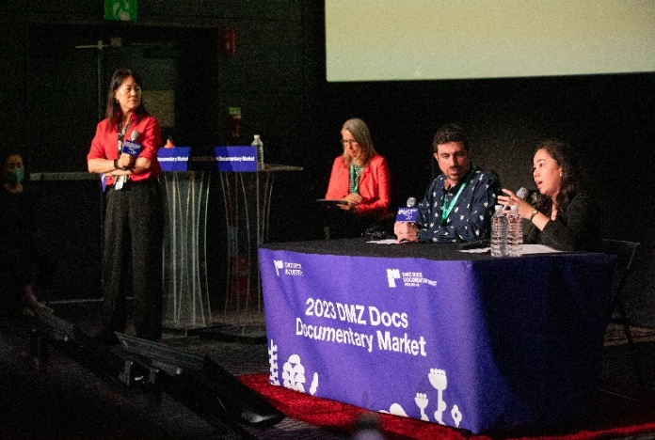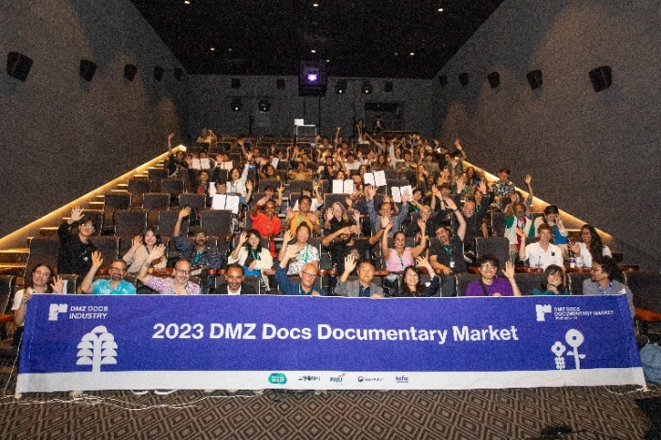

[(Left) Photo of 2023 DMZ Docs Documentary Market Awarding Ceremony

(Right) Photo of 2023 DMZ Docs Industry Pitch]

The DMZ International Documentary Film Festival (Festival Director Chang Hae Rang, hereinafter DMZ Docs) aims to promote the values of “Peace, Life, and Communication” through documentaries, and announces 19 selected projects to participate in the 2024 DMZ Docs Industry Pitch, held from September 28 (Sat) to October 2 (Wed).

Since 2019, DMZ Docs Industry has been discovering, training, fostering, and supporting production costs for outstanding documentary projects in Korea and Asia. The DMZ Docs Industry also arranged a documentary market during the film festival period to expand opportunities for filmmakers to interact and communicate with the global documentary industry agents.

Among DMZ Docs Industry’s production support categories, “DMZ Docs Pitch” is a program that discovers and introduces Korean and Asian documentary projects to global documentary industry agents. For documentary filmmakers who are producing meaningful documentaries in tough environments, the DMZ Docs Pitch provides an invaluable opportunity to receive feedback from experts and secure funding by identifying key demands. The Pitch also offers prize money to the winners and arranges individual business meetings between all participants, broadcasting commissioners, film agents, sales agents, and distributor agents.

“DMZ Docs Pitch” called for entries from May 20 to June 10, and a total of 164 entries were submitted from 33countries. Both Production Pitch and Rough Cut Pitch entries were divided into Korea and Asia categories and reviewed by a selection committee composed of Korean and global documentary experts. The Production Pitch Korean Projects were reviewed by JANG Byung-won (DMZ Docs Program Director), AN Boyoung (FILMYOUNG CEO), and LEE Changjae (Graduate School of Advanced Imaging Sciences, Multimedia & Film of CAU, Professor). The Asian Projects were reviewed by KIM Young (MIRU Pictures, Producer), Gunny HYOUNG (EIDF, Artistic Director), and FUJIOKA Asako (Documentary Dream Center, Director). The Rough Cut Pitch Korean Projects were reviewed by OH Jung Hoon (DMZ Docs, Deputy Director), KIM Wonjoong (SJM Cultural Foundation, General Manager), and MOON Sung (Jeonju IFF, Programmer). The Asian Projects were reviewed by KANG Jinseok (DMZ Docs, Programmer), Keisha KNIGHT (IDA Funds, Funds & Advocacy Director), and THONG Kay Wee (SGIFF (Singapore International Film Festival), Programme Director).

This year’s Production Pitch entries keenly and closely capture various historical and contemporary issues in Korea and Asian countries. The entries are produced by diverse filmmakers, including veteran directors with an accomplished world of cinematic artwork and emerging directors with a fresh and novel world of artwork. A selection committee member who reviewed the Korean entries commented, “I could feel each project’s efforts to cover a wide range of topics and to view diverse and sharp issues in Korean society from their own point of view. I also could feel each producer’s struggles to complete the works even in tough conditions.” The Rough Cut Pitch called for documentary projects in rough cut stage and to be completed by 2025. The selected entries of the Rough Cut Pitch showed remarkable diversity and high-level completeness. A selection committee member said, “We selected the works based on novelty of topic, appealing power, expectation for completeness, and need of pitch benefits.” These are works that will make a meaningful impact on the national and international documentary scene in the future.

The selected DMZ Docs Pitch projects will be participating in the Public Pitch during the DMZ Docs Industry period and will have the opportunity to take part in one-on-one business meetings with global documentary industry agents. After the Public Pitch, a total of 250 million won will be granted to all selected projects, and there will be additional assistance in-kind and investment funds for completing the project.

The 16th DMZ International Documentary Film Festival will be screening about 120 Korean and international documentaries, and it will be held for 7 days from September 26 to October 2, in Paju City and Goyang Special City of Gyeonggi Province.

■ 2024 DMZ Docs Pitch - Production Pitch (13)

|  |  |  |  |
| --- | --- | --- | --- |
| **Korea** | | | |
|  | **Title** | **Director** | **Production Country** |
| 1 | The Silent Bride | CHO Eunsol | Korea |
| 2 | Where We Stay for a While | WANG Mincheol | Korea |
| 3 | Drawing a flower of time | JUNG Dawoon | Korea |
| 4 | Way to Go Home | LEE Insub | Korea |
| 5 | A Tree of One Thousand Years | HWANG Yun | Korea |
| 6 | EACH AND EVERY BEING IS EVERYTHING UNTO ITSELF | JANG Yunmi, LEE Suyu | Korea |
| 7 | 1948, Forgotten Soldiers | HEO Steven Wook | Korea |
| **Asia** | | | |
|  | **Title** | **Director** | **Production Country** |
| 1 | Black River | TRAN Phuong Thao, Swann DUBUS | Vietnam |
| 2 | The Last Shepherd | Anil BUDHA MAGAR | Nepal |
| 3 | Letters from Home | Xin FANG, Chenyu KOU | China, USA |
| 4 | South Sea | Riar RIZALDI | Indonesia |
| 5 | Umbrellas of the Acrobats | Mukesh SUBRAMANIAM | India |
| 6 | Wind and View | SHENG-HUNG Hsieh | Taiwan, Germany, Japan |

■ 2024 DMZ Docs Pitch - Rough Cut Pitch (6)

|  |  |  |  |  |
| --- | --- | --- | --- | --- |
| **Korea** | | | | |
|  | **Title** | **Director** | **Production Country** | |
| 1 | Daughter of the Vampire Deer | YU Soyoung | Korea | |
| 2 | Returning Figures | KIM Mooyoung | Korea | |
| 3 | Red Diary | LIM Daecheong | Korea | |
| **Asia** | | | |
|  | **Title** | **Director** | **Production Country** |
| 1 | ALWAYS | Deming CHEN | China, USA |
| 2 | Redlight to Limelight | BIPULJIT BASU | India |
| 3 | What’s Your Problem with Love? | Trang Thi Minh DAO | Vietnam, Korea |