**DMZ International Documentary Film Festival**

**DMZ Docs Industry Calls Entries for ‘DMZ Docs Pitch’ Project**

Discovery and Introduction of Korean and Asian Documentary Projects

Two Categories: Production Pitch & Rough Cut Pitch

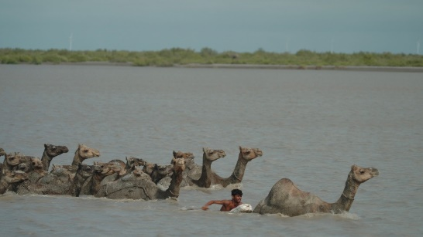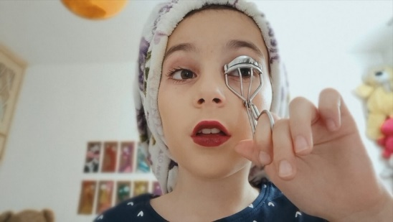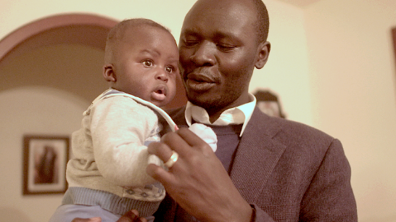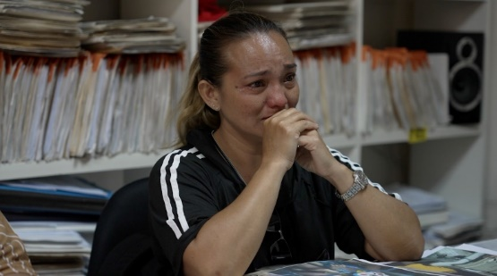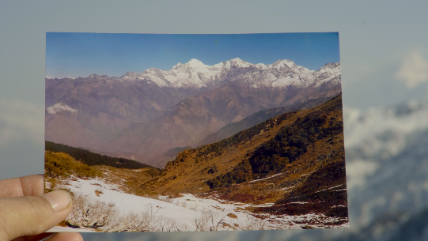

[2023 DMZ Docs 인더스트리 ‘DMZ Docs 피치’ 수상작]

The DMZ International Documentary Film Festival (Festival Director Chang Hae Rang, hereinafter DMZ Docs) aims to promote the values of “Peace, Life, and Communication” through documentaries, and calls entries for the DMZ Docs Pitch project of DMZ Docs Industry starting from May 20 (Mon).

Since 2019, DMZ Docs Industry has managed a documentary market that discovers outstanding documentary projects, train people, supports production costs, and expands opportunities for domestic and global distribution through networking with overseas industry experts.

DMZ Docs Pitch is a program that discovers and introduces Korean and Asian documentary projects with strong appeal in the global documentary market. For documentary filmmakers who are producing meaningful documentaries in challenging environments, the DMZ Docs Pitch provides an invaluable opportunity to receive feedback from experts and secure funding by identifying key demands. The Pitch also offers prize money to the winners and arranges an individual meeting between all participants, broadcasting commissioners, film agents, sales agents, and distributors.

DMZ Docs Pitch has two categories : ‘Production Pitch’ for projects 30% to 70% in production and ‘Rough Cut Pitch’ for projects in rough cut. The projects shall be submitted online to the DMZ Docs Industry website until June 10 (Mon). For details, please refer to the DMZ Docs website (http://industry.dmzdocs.com/).

The 16th DMZ International Documentary Film Festival will feature about 120 domestic and international documentaries, and will be held for 7 days from September 26th to October 2nd at Paju-si and Goyang Special City, Gyeonggi-do.

■ Notice on 2024 DMZ Docs Industry “DMZ Docs Pitch” Entry

**1. Entry Overview**

A. Support

|  |  |  |
| --- | --- | --- |
|  | **Production Pitch** | **Rough Cut Pitch** |
| **Number of Selected Projects** | Within 13 Korean and Asian projects | Within 6 Korean and Asian projects |
| **Supports & Benefits** | • Prize money is granted based on pitching evaluation results  - (Grand Prize) 30 million KRW x 1 project  - (Best Prize) 20 million KRW x up to 3 projects  - (Excellence Prize) 10 million KRW x 10 projects (more or less) | • Prize money is granted based on pitching evaluation results  - (Best Prize) 15 million KRW x up to 2 projects  - (Excellence Prize) 10 million KRW x 5 projects (more or less) |
| • Invitation to 2024 DMZ Docs Industry (Pitch and BizMatch)  • Online Tutoring | • Invitation to DMZ Docs Industry 2024 (Pitch and BizMatch)  •One-to-One Editing Consultation provided (online) |

* Number of selected projects and prize money may change depending on circumstances.

B. Target Projects

|  |  |
| --- | --- |
| **Production Pitch** | • Documentary projects within 30-70% of stage production |
| **Rough Cut Pitch** | • Projects in rough cut editing stage  • Projects that have never been released or broadcast (as of September 2024) |
| **Both Production & Rough Cut Pitch** | • Feature-length (over 60 min.) documentary projects  • Documentary projects created by director/producers of Korean or Asian nationality  • The copyright must be held by the creator or applicant as an original work of art intended for screening on multiple platforms, including its theatrical release  • Projects with original work, if any, for which rights have been secured  • In case the project is funded by other festival/organizations, be sure to indicate whether the other festival/organization has the first look deal option |

**2. Submission Period and How to Submit**

A. Submission Period : 2024.05.20.(Mon) – 2024.06.10.(Mon) 17:00 (KST)

B. How to Submit

Online Submission to DMZ Docs Industry Website <https://industry.dmzdocs.com/kor/default.asp>

**3. Inquiry**

DMZ International Documentary Film Festival Industry Team

E-mail. [submit.industry@dmzdocs.com](mailto:submit.industry@dmzdocs.com)

Tel. +82 (0)31-936-7381